# Text 1 – Oded Galor (2022), *The journey of Humanity. The origins of wealth and inequality*, Dutton, Pinguin House (selected pages from chapters 1 to 10).[1]

## Introduction

Imagine that some residents in Jerusalem 2,000 years ago, were to step into a time machine and travel to the Ottoman-ruled Jerusalem of 1800. They would undoubtedly be impressed by the magnificent new city wall, the considerable population growth, and the adoption of new innovations. But although nineteenth-century Jerusalem was quite different from its Roman predecessor, our time travellers would adjust with relative ease to their new surroundings. Admittedly, they would adapt their behaviour to the new cultural norms, but they would be able to maintain the trades they had practised at the dawn of the first century and sustain themselves easily enough, since the knowledge and skills acquired in ancient Jerusalem would still be pertinent at the turn of the nineteenth century. They would also find themselves vulnerable to similar perils, illnesses, and natural hazards as those endured in the Roman period, and their life expectancies would hardly alter.

Envision, however, the experience of our time travellers if they were whisked away in our time machine again, just another two hundred years ahead, to early-twenty-first-century Jerusalem. They would be utterly astounded. Their skills would now be obsolete, formal education would be a prerequisite for most occupations, and technologies that might seem like witchcraft would be daily necessities. Furthermore, as numerous fatal diseases of the past would have been eradicated, their life expectancy would instantly double, requiring an entirely different mindset and longer-term approach to life.

The gulf between these eras makes it difficult to conceive the world we left behind not so long ago. As the seventeenth-century English philosopher Thomas Hobbes put it bluntly, human life was nasty, brutish, and short. At the time, a quarter of new-borns died of cold, hunger and assorted illnesses before reaching their first birthday, women often perished during childbirth, and life expectancy rarely exceeded forty. It was a place where women, men and children devoted long hours to ferrying water to their homes, washed infrequently, and spent the winter months in smoke-filled homes. A time in which most people lived in far-flung rural villages, rarely ventured from their birthplace, survived on paltry and monotonous diets, and could neither read nor write. A dismal era when an economic crisis did not simply demand belt-tightening, but rather led to mass starvation and death. Many of the daily hurdles that concern individuals in the present-day pale in comparison to the hardships and tragedies faced by our not-so- distant forebears.

It has long been the prevailing wisdom that living standards have risen incrementally over the entire course of human history. This is a distortion. While the evolution of technology has indeed been a largely gradual process, accelerating over time, it has not resulted in a corresponding improvement in living conditions. The astounding ascent in the quality of life in the past centuries has in fact been the product of an abrupt transformation. […]

Since the dawn of the nineteenth century, a split second compared to the span of human existence, life expectancy has more than doubled, and per capita incomes have soared twenty-fold in the most developed regions of the world, and fourteen-fold on Planet Earth as a whole (Fig. 1). This continuing improvement has been so radical, in fact, that we often lose sight of just how exceptional this period is in relation to the rest of our history. What explains this Mystery of Growth – the scarcely conceivable transformation in the quality of life of the last few centuries, in terms of health, wealth and education, which dwarf any other changes in these dimensions since the emergence of Homo sapiens?

In 1798, the English scholar Thomas Malthus offered a plausible theory for the mechanism that had caused living standards to remain stagnant, effectively trapping societies in poverty, since time immemorial. He argued that whenever societies managed to bring about a food surplus through technological innovation, the resulting boost in living standards could only ever be temporary as it would lead inevitably to a corresponding rise in birth rates and a reduction in mortality rates. It was just a matter of time, therefore, before the ensuing population growth would deplete the food surpluses, and thus living conditions would revert to subsistence levels, leaving societies as poor as they had been before the innovation.

Indeed, during the period known as the Malthusian epoch – which is to say, the entirety of human history up until the recent dramatic leap forward – the fruits of technological advancements were channelled primarily towards larger and denser populations and had only a glacial impact on their long- term prosperity. Populations grew while living conditions stagnated and remained near subsistence. Variations between regions in terms of the sophistication of their technology and the productivity of their land were reflected in differing population densities, but the effects they had on living conditions were largely transitory. Ironically, however, just as Malthus completed his treatise and pronounced that this ‘poverty trap’ would endure indefinitely, the mechanism that he had identified suddenly subsided and the metamorphosis from stagnation to growth took place.

How did the human species break out of this poverty trap? What were the underlying causes of the extent of this epoch of stagnation? Might the forces that governed both the protracted economic ice age and our escape from it foster our understanding of why current living conditions are so unequal across the globe?

Fuelled by the conviction, and the evidence, that in order to understand the causes of the vast inequality in the wealth of nations we would have to identify the principal driving forces behind the process of development as a whole […] this book explores and identifies the forces that have governed the development process. It demonstrates how these forces operated relentlessly, if invisibly, throughout the course of human history, and its long economic ice age, gathering pace until, at last, technological advancements in the course of the Industrial Revolution accelerated beyond a tipping point, where rudimentary education became essential for the ability of individuals to adapt to the changing technological environment. Fertility rates started to decline and the growth in living standards was liberated from the counterbalancing effects of population growth, ushering in long-term prosperity that continues to soar in the present day. At the centre of this exploration is the question of the sustainability of our species on Planet Earth. Today, the impact of the growth process on environmental degradation and climate change raises significant concerns as to how our species might live sustainably and avert the catastrophic demographic outcomes of the past.

The journey of humanity provides a hopeful outlook: the tipping point that the world has recently reached, resulting in a persistent decline in fertility rates and the acceleration of ‘human capital’ formation and technological innovation, could enable humanity to mitigate these detrimental effects and will be central for the sustainability of our species in the long run.

Intriguingly, when prosperity skyrocketed in recent centuries, it did so only in some parts of the world, triggering a second major transformation unique to our species: the emergence of immense inequality across societies. One might suppose that this phenomenon occurred primarily because the escape from the epoch of stagnation has occurred at different times across the globe. Western European countries and some of their offshoots in North America and Oceania experienced the remarkable leap in living conditions as early as the nineteenth century, while this ascent was delayed in most regions of Asia, Africa and Latin America until the latter half of the twentieth century (Fig. 2).

[…] Uncovering the deep-rooted factors behind this global disparity leads us to reverse the course of our journey and to take major sequential steps far back in history, ultimately reverting to the place where it all began – the exodus of Homo sapiens from Africa tens of thousands of years ago.

## The Malthusian regime

Like other species, over most of their existence, humans were caught in a trap of hardship and privation, near the subsistence level.

Despite some regional differences, income per capita and wages for unskilled labourers in different civilisations fluctuated within only a very narrow band for thousands of years. In particular, estimates suggest that wages for a workday were the equivalent of seven kilograms of wheat grains in Babylon and five kilograms in the Assyrian Empire more than three thousand years ago, eleven to fifteen kilograms in Athens more than two thousand years ago, and four kilograms in Egypt under the Roman Empire. In fact, even on the eve of their Industrial Revolution, wages in Western European countries remained in this narrow range: ten kilograms of wheat in Amsterdam, five in Paris, and three to four in Madrid, Naples and assorted cities in Italy and Spain.

Moreover, skeletal remains across various tribes and civilisations over the past 20,000 years indicate that despite some regional and temporary differences, life expectancy (at birth) oscillated within a very narrow band. Remains uncovered in Mesolithic sites in North Africa and the Fertile Crescent suggest that life expectancy was nearly thirty years. During the subsequent Agricultural Revolution it did not change significantly in most regions, though it dropped in some~~.~~ In particular, skeletons exhumed from burial sites dating from the early stages of the Neolithic Revolution, 4,000 to 10,000 years ago, suggest that life expectancy was about thirty to thirty-five at Çatalhöyük (Turkey) and Nea Nikomedeia (Greece), twenty at Khirokitia (Cyprus), and thirty near the towns of Karataş (Turkey) and Lerna (Greece). Two and a half thousand years ago, life expectancy reached about forty years in Athens and Corinth, but headstones from the Roman Empire indicate yet again an age at death in the range of twenty to thirty. More recent evidence points to fluctuations in life expectancy in the range of thirty to forty years in England from the mid-sixteenth to nineteenth centuries, and comparable values were recorded in pre-industrial France, Sweden and Finland.

For nearly 300,000 years after the emergence of Homo sapiens, per capita incomes were scarcely higher than the minimum necessary for survival, plagues and famines were abundant, a quarter of babies did not reach their first birthday, women commonly perished during childbirth, and life expectancy rarely exceeded forty years.

[In 1798], Malthus published *An Essay on the Principle of Population,* in which he […] advanced the gloomy thesis that in the long run humanity could never prosper because any gains it made would ultimately be depleted by population growth […]

In retrospect, Malthus’s description of the world as it existed in the past was entirely accurate. It was his pessimistic predictions about the future of humanity that turned out to be utterly mistaken.

Imagine a village in the pre-industrial age where the inhabitants devise a more efficient method to grow wheat using iron ploughs, considerably increasing their ability to produce bread. At first, the villagers’ diets would improve and, trading some of the surplus, their living conditions would rise. The abundance of food might even enable them to reduce their work and enjoy some leisure. But critically, Malthus argued, this surplus would allow them to sustain more surviving children, and accordingly the village’s population would grow over time. And since the land available for wheat cultivation within the village is necessarily limited, this population growth would gradually lead to a reduction in each villager’s bread ration. Living standards would begin to drop after the initial rise and would only stop falling once the ratio of loaves per villager returned to its original level. Painfully, their technological progress would lead to a larger but not a richer population in the long run.

This trap has had all living beings in its clutches. Consider a pack of wolves on an island. Global cooling causes sea levels to drop and uncovers a land bridge to another island, which is home to a peaceful population of rabbits. The wolves gain new hunting grounds, the availability of additional prey boosts their living standard, and more cubs survive to reach maturity, leading to an explosion of the wolf population. However, as more wolves must share a limited amount of rabbits, the wolves’ living standard gradually reverts to the pre-cooling level, while the wolf population stabilises at a larger size. Access to more resources does not make the wolves better off in the long run.

The Malthusian hypothesis is based on two fundamental building blocks. The first is that a rise in resources (agricultural yields, fishing hauls, and hunting and gathering bounties) leads populations to have more surviving offspring, driven by the biological, cultural and religious predisposition to reproduce, and the decline in child mortality that accompanies better nourishment. The second building block is that population growth engenders a decline in living conditions whenever living space is limited. According to Malthus, the size of any population will adapt to the available resources via two mechanisms: the positive check – a rise in mortality rates due to the increased frequency of famine, disease and war over resources in societies whose populations have outgrown their food production; and the preventative check – a drop in birth rates during periods of scarcity through delayed marriage and the use of contraception.

Did technological advancements in the pre-industrial era lead to larger but not richer populations as implied by the Malthusian thesis? The evidence is clear that technological sophistication and population size were indeed positively associated in this era, but the existence of this relationship does not in itself indicate an impact of technology on population. In fact, technological advancements during this period were partly the result of larger populations because sizeable societies produced both more potential inventors and greater demand for their inventions. Besides, it may be that other independent factors – cultural, institutional or environmental – contributed to the growth of both technology and population, thus accounting for the positive correlation between the two. In other words, this correlation cannot in itself be taken as evidence of Malthusian forces.

Fortunately, the Neolithic Revolution provides us with an intriguing way to test the validity of the Malthusian thesis. […] We can therefore infer a region’s level of technological advancement from our knowledge of when it underwent the Neolithic Revolution (or from the number of domesticable species of plants and animals in the region). Put another way, at any single point in time, regions that had undergone the Neolithic Revolution earlier would be expected to have higher levels of technological sophistication. Thus, all other factors being equal, if a region that underwent the Neolithic Revolution earlier is also larger or richer, we can confidently conclude that this has been caused by its level of technological advancement. Using this approach, we can indeed observe the Malthusian mechanism at work prior to the industrial era. In 1500 cE, for instance, higher technological level, as inferred from an earlier onset of the Neolithic Revolution, did indeed lead to greater population density, whereas the impact on per capita income was negligible (Fig. 4).

Separate evidence, meanwhile, shows that fertile soil also contributed to higher population density but not to higher living standards. And examining even earlier eras through the same lens reveals an impressively consistent pattern – technological advancements and higher land productivity led primarily to larger but not richer populations, implying that prior to the Industrial Revolution, people across the world enjoyed largely similar standards of living.

## The wheels of change

What, then, propelled humanity out of the gravitational forces of the Malthusian equilibrium? How did the world wrench itself out of this economic black hole?

In search of the catalyst of the transition from stagnation to growth, one may argue that the Industrial Revolution is the force that gave the world an abrupt external shock that jolted it into the modern phase of growth. However, evidence from the eighteenth and nineteenth centuries when the Industrial Revolution occurred suggests that there was no ‘jolt’ at any point during this period. While the transition was rapid when compared with the timespan of human history, the productivity gains experienced during this period increased gradually. Indeed, when the Industrial Revolution first transpired, since technological change was incremental, populations spiked but average incomes increased only very modestly, just as would be predicted by the Malthusian theory. Yet, at a certain point, nearly a century later, the Malthusian equilibrium quite mysteriously vanished and tremendous growth ensued. The conceptual framework I devised in the past few decades to address this conundrum was inspired by insights from the mathematical field of bifurcation theory, which demonstrate how, beyond a certain threshold, minor alterations in a single factor may generate a sudden and dramatic transformation in the behaviour of complex dynamical systems (as is the case when heat crosses a threshold and transforms water from liquid to gas). In particular, this research has focused on identifying the cogs that were whirring invisibly beneath the surface, wheels of change that were turning relentlessly throughout the epoch of the Malthusian equilibrium but which ultimately broke its hold and led to the emergence of modern growth – much like the rising temperatures in the kettle.

What are those mysterious wheels of change that operated persistently during the Malthusian epoch and ultimately triggered the dramatic metamorphosis in living standards in the past two centuries?

One of these wheels of change was population size. At the eve of the Neolithic Revolution, in the year 10,000 BCE, an estimated 2.4 million human beings roamed the Earth. Yet, by the year 1 cE, as the Roman Empire and the Mayan civilisation approached their height, the world’s population had multiplied seventy-eight-fold, and soared to 188 million. A millennium later, when the Vikings raided the coasts of Northern Europe and the Chinese first used gunpowder in combat, humanity stood at 295 million individuals. World population had risen to nearly half a billion by the year 1500, at the time when Columbus was in the midst of his expeditions to the Americas, and at the turn of the nineteenth century, in the early phases of industrialisation, the human population nearly crossed the one billion mark (Fig. 6).

The relationship between population size and technological change is a reciprocal one – just as technological advancements during the Malthusian epoch enabled populations to densify and grow 400-fold within a 12,000- year period, so had the size of these human populations contributed to an acceleration in the pace of innovation. As noted above, larger populations were more likely to generate both a greater demand for new goods, tools and practices, as well as exceptional individuals capable of inventing them. Moreover, sizeable societies benefited from more extensive specialisation and expertise, and greater exchange of ideas through trade, further accelerating the spread and penetration of new technologies. As we have seen, this self-reinforcing, positive feedback loop emerged at the very dawn of the human species and it has been operating ever since.

This impact of population size on the technological level is apparent across cultures and regions throughout the historical record. Regions that experienced an earlier onset of the Neolithic Revolution, such as the Fertile Crescent, gave rise to the largest prehistoric settlements and enjoyed a persistent technological head start […] Larger populations were not only more conducive to technological development, but they also prevented the kind of technological decline that is a common feature of smaller communities, such as that experienced by the Polar Inuit of north-west Greenland in the 1820s. This society was hit by an epidemic that decimated its adult population, who were the store for the tribe’s priceless technological knowledge, such as for kayak construction. In its aftermath, the young survivors could not restore this lost technological know-how, since even the possessions of the old were buried with them, and experienced an extreme technological regression, which drastically eroded their hunting and fishing capabilities. Their population began to dwindle and would surely have continued to wane had they not eventually encountered another Inuit community, who reintroduced them to this lost knowledge a few decades later. Acute technological regression among isolated communities had been experienced by other small communities, such as Aboriginal Tasmanian tribes after the loss of their land bridge with Australia. In contrast, technological regression is much rarer in larger populations which tend to have trading links with other groups, spread their knowledge across society, and enjoy regular infusions of new inventions.

As will become apparent, this reinforcing cycle – technological development sustaining larger populations, while larger populations reinforce technological development – which has operated throughout most of our existence, gradually but continuously intensified until ultimately the rate of innovations reached a critical threshold. This was one of the sparks for the phase transition that hoisted humanity out of the epoch of stagnation.

Population size operated in tandem with another wheel of change – population composition. […] During the Malthusian epoch, it is reasonable to suppose that cultural traits that were complementary to the technological environment would have generated higher income, and thus a larger number of surviving offspring, leading therefore to a gradual increase in the prevalence of these traits in the population. And because these traits would in turn reinforce that pace of technological change, they would have contributed to the pace of the development process from stagnation towards growth. As we will see, among the most growth-enhancing of these cultural traits would have been norms, attitudes and customs associated with placing a high value on education, having a ‘future-oriented’ mindset and embracing what we might call an ‘entrepreneurial spirit’.

This process is epitomised by the evolution of the cultural inclination for parental investment in ‘human capital’ – factors that influence worker productivity, such as education, training and skill, along with health and longevity. Consider a human population caught in the Malthusian equilibrium that consists of two large clans: the Quanty and the Qualy. The Quanty clan adheres to the cultural norm, ‘be fruitful and multiply’ (Genesis 9:1), bringing as many children as possible into the world and investing its limited resources in raising them. In contrast, the Qualy clan pursues an alternative custom: its members choose to have fewer children but they invest a considerable part of their time and resources in factors that influence their children’s productivity and earning capacity. Which of the clans, the Qualy or the Quanty, will have more descendants and thus dominate the overall population in the long run?

Suppose that Quanty households bear on average four children each, of whom only two reach adulthood and find a reproductive partner. Meanwhile, Qualy households bear on average only two children each, because their budget does not allow them to invest in the education and health of additional offspring, and yet, thanks to the investment that they do make, both children not only reach adulthood and find a reproductive partner but they also find jobs in commercial and skill-intensive occupations, such as blacksmiths, traders and carpenters. At this stage, neither the fraction of Quanty nor Qualy is expanding over time and the composition of the population remains stable. But now suppose the society in which they live is one where technological development boosts the demand for the services of blacksmiths, carpenters and other trades who can manufacture tools and more efficient machines. This increase in earning capacity would place the Qualy clan at a distinct evolutionary advantage. Within a generation or two, its families are likely to enjoy higher incomes and amass greater resources. Their offspring will then be able to afford to bear on average, say, three children, educate all three of them, raise them to adulthood, and marry them off. In contrast, the uneducated offspring of the Quanty clan will not be affected by this technological development, their incomes will remain unchanged, and thus, on average, still only two children from each Quanty household will be likely to reach adulthood.

This mechanism suggests that in societies where technological innovation offers economic opportunity and thus where reproductive success is enhanced by the investment in human capital that allows one to seize it, a positive feedback loop will lead the Qualy clan to dominate the population in the long run: the increasing dominance of Qualy families will foster technological progress, while technological progress will increase the share of Qualy families in the population.

These, then, were the wheels of change that have been whirring beneath the surface for the entire course of human existence: technological innovations sustained larger populations and triggered the adaptation of the human population to their ecological and technological environments; larger and more adapted populations fostered in turn the ability of humankind to design new technologies and gain increasing control of their environment. Taken together, it was these wheels of change that led ultimately to a spectacular explosion of innovations on a scale never seen before in human history – the Industrial Revolution.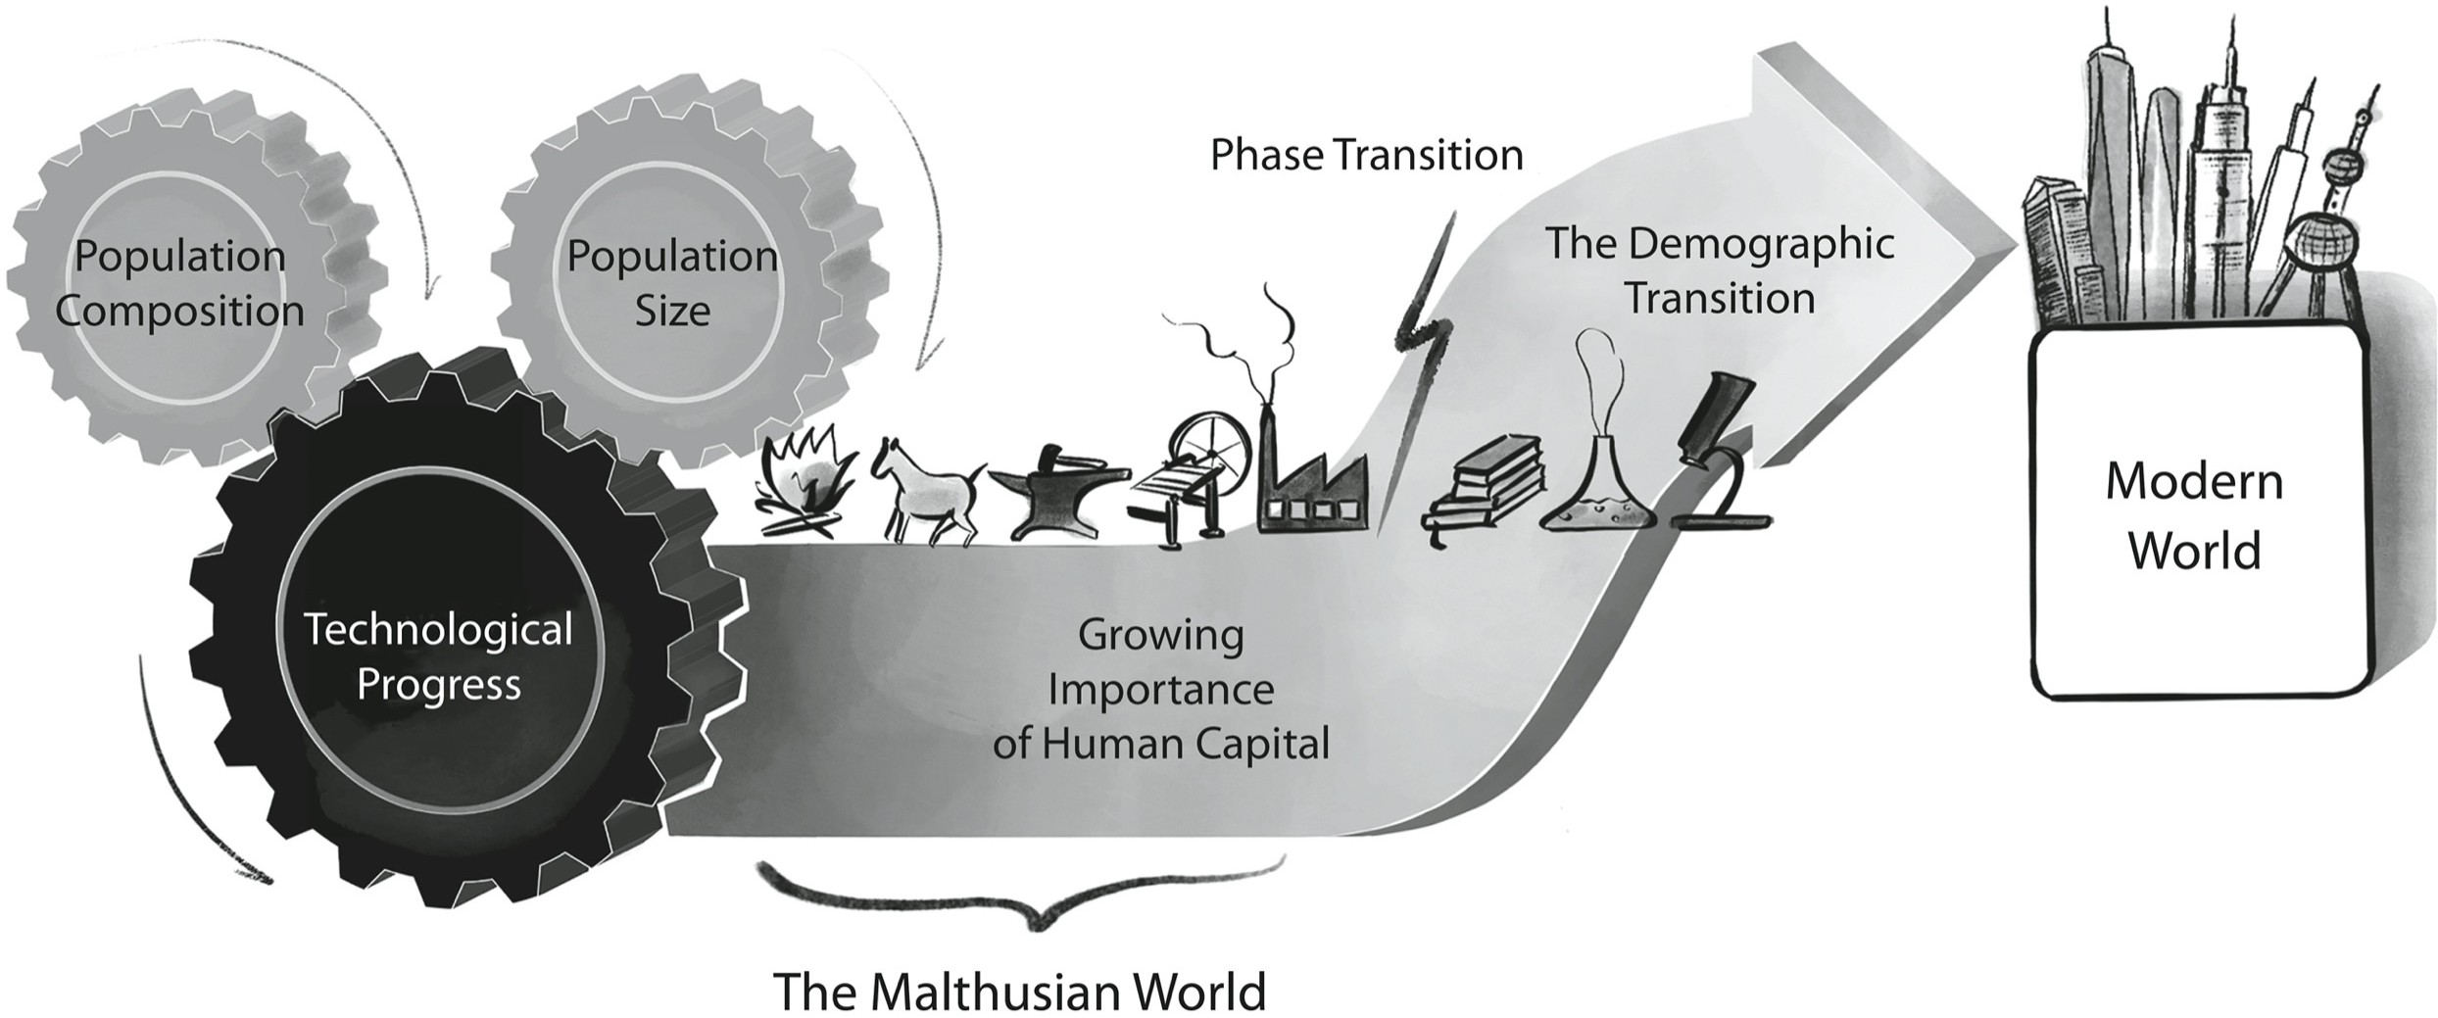

## Wealth and Inequality:

In the past decade, scores of boats overloaded with migrants from Africa have sunk just off the coast of Libya and thousands of passengers have lost their lives. In 2015 alone, more than a million people crossed the Mediterranean in similar crafts, and over the course of this ongoing humanitarian crisis many thousands more from Africa, the Middle East and Latin America have died attempting to reach European and US borders. This desperate mass exodus, in which people not only endanger their lives but leave behind their families and homeland, and pay considerable sums they can scarcely afford to human traffickers, is primarily a result of the immense inequality in living standards across world regions […] At the surface of this global inequality is the fact that income per capita in developed nations is significantly higher than that in developing countries (Fig. 14), resulting in a much higher expenditure on education, health care, nutrition and housing.

But why do the citizens of some countries earn significantly more than the residents of others? This earning gap partly reflects differences in ‘labour productivity’: each hour of work in some world regions produces goods or services of greater value than an equivalent hour of work elsewhere. Agricultural labour productivity, for instance, varies enormously across countries. In the United States agricultural productivity per worker in 2018 is nearly 147 times higher than in Ethiopia, 90 times higher than in Uganda, 77 times higher than in Kenya, 46 times higher than in India, 48 times higher than in Bolivia, 22 times higher than in China and 6 times higher than in Brazil. But again, why do American farmers reap a far bigger harvest than the farmers of sub-Saharan Africa, South East Asia and most of South America?

The answer should come as no surprise: these differences are primarily a reflection of the technologies for cultivation and harvesting that are used in each country, as well as the skills, education and training of farmers. American farmers use tractors, trucks and combine harvesters, for example, while farmers in sub-Saharan Africa are more likely to rely on wooden ploughs often pulled by oxen. Moreover, American farmers are better trained and can use genetically modified seeds, advanced fertilisers and refrigerated transportation, which may not be feasible or profitable in the developing world.

Nonetheless, this chain of proximate causes does not shed light on the roots of the disparity. It simply directs us to a more fundamental question: Why does the production process in certain countries benefit from more skilled workers and more sophisticated technologies?

Previous attempts to understand economic growth, like that of Nobel Prize- winning economist Robert Solow, focused on the importance of the accumulation of physical capital – straw baskets, rakes, tractors and other machines – to economic growth.

Suppose that a couple harvests enough wheat to bake a few dozen loaves of bread a week. They use some of these loaves to feed their family and sell the remainder at the village market. Once they have saved enough, they purchase a plough, increasing their stock of physical capital, their harvests and ultimately the number of loaves of bread they can bake per week. As long as the couple does not have additional children, this accumulation of capital (the addition of a plough) will help them increase their per capita income. The impact of this physical capital accumulation, however, is constrained by the law of diminishing marginal productivity: as the amount of land and time available to them is limited, then if that first plough boosts the couple’s output by five loaves of bread a week, a second plough might only contribute three more loaves, while the fifth plough may hardly boost productivity at all.

The important corollary of this analysis is that only perpetual improvements in the efficiency of the plough will deliver long-term income growth for these villagers. Furthermore, the acquisition of a new plough would spur faster growth on a poor farm than it would on a more advanced farm of equal size, because this would likely be the first on the poor farm, whereas it might be the third or the fourth on the rich one. Thus, a relatively poor farm should grow more quickly than a more advanced one, and over time the income gap between the poor and the rich farms should narrow.

Solow’s growth model suggests therefore that economic growth cannot be sustained indefinitely in the absence of technological and scientific progress. Moreover, it predicts that, with time, income disparities between countries that differ only in their initial levels of per capita income and capital stocks should diminish.

Imagine a marathon race in which the further runners get from the starting point the harder each additional step becomes. If one group of runners starts the race a few minutes earlier than a second, equally talented group of runners, the first group will keep ahead of the latecomers, but the gap between the two will be narrowing with every stride they take. Analogously, in the context of countries that differ only in their initial levels of per capita income and capital stock, those poorer economies that started the race later should gradually converge with those richer economies that started the race earlier, and thus the income gaps across these nations should eventually decline.

Yet, as Figure 15 shows, the economies of the developed and developing nations have not converged. Quite the contrary, in fact: the gaps in living standards between regions have largely expanded over the past two centuries.

What prompted this great divergence between some countries? And what are the forces that have prevented some poorer nations from catching up with richer ones?

In the second half of the twentieth century, policymakers advanced programs with the aim of raising the living standards of developing countries based on the insight that technological progress and the accumulation of physical and human capital stimulate economic growth. However, inequality across nations persists to such an extent as to suggest that these policies have had a limited impact. Too narrow a focus on observable factors on the surface – the manifested disparities – rather than on the underlying causes that created them has prevented the design of policies that would help poorer nations overcome the less visible, but more persistent, obstacles they face. These forces could have created a barrier that inhibited investments, education and the adoption of new technologies, contributing to uneven development across the globe. It is these underlying causes and obstacles that we will need to identify if we wish to decipher the Mystery of Inequality and foster global prosperity.

## 

## The Power of Culture

Cultural traits – the shared values, norms, beliefs and preferences that prevail in a society and are transmitted across the generations – have often made a significant impact on a society’s development process. In particular, aspects of culture that dispose populations towards or away from the maintenance of strong family ties, interpersonal trust, individualism, future orientation and investment in human capital have considerable long-term economic implications.[6]

The boundary between cultural and personal traits may often appear fuzzy. Some people might invest heavily in the education of their young because of the values of their social, ethnic or religious group, while others may be driven by personal traits, reflective of their life experiences, upbringing and family background. Nonetheless, one’s values, beliefs and preferences are rarely independent of one’s social and cultural context. And when variations in these norms correlate clearly with ethnic, religious or social groupings, it is plausible that they are, to a large extent, a manifestation of cultural rather than individual differences. In other words, it is the cultural component that is pertinent for the understanding of inequality across groups.

So how have cultural traits emerged and persisted and how have they affected the evolution of societies in the course of human history?[…] Like biological mutations, the initial appearance of a cultural change may be ‘random’, but its survival or extinction is not accidental. The norm of literacy and book-learning might never have appeared in either the Jewish or Protestant communities without the decree of the Jewish sages and the preaching of Luther; but it is nearly certain it would never have taken root in the way that it did were it not for the advantages – in this case commercial and economic – bestowed on those who embraced it, advantages that the early advocates of Bible study neither envisioned nor invoked.

Different societies in different places at different times have inevitably developed different norms in order to adapt to the particular ecologies they inhabit. Over time and across civilisations, thinkers and leaders have proposed countless initiatives to reform norms, values and beliefs. Yet it is mostly when either geographical and climatic characteristics, the disease environment, or technological, commercial and social conditions have reinforced the benefits of these novel cultural traits that they have persisted and generated significant cultural change.

Humans have developed traditions and norms that regulate, for example, diet, property rights, social cohesion, family structure and gender role. Individuals within these societies often consider these traditions to be based on timeless and essential truths, commonly adhering to and perpetuating them as such, without necessarily knowing their original purposes or understanding the adaptive reasons for their existence. This psychological tendency to adhere to existing cultural norms without challenging their foundations has conferred a survival advantage. Societies with hardly any scientific knowledge of human biology, group consciousness or the ecological factors that affect their habitats have been able to thrive in complex and precarious environments, behaving as if they did possess such knowledge, thanks to accumulated wisdom of generations of trial and error, passed on in the form of ancient traditions, timeless beliefs and universal rules […]

But then a dramatic transformation occurred in one region of the world that galvanised growth-enhancing traits, leading to ‘a culture of growth’ […] [F]orward-looking philosophers started to gain the upper hand over their rivals. Thus wrote Immanuel Kant in his 1784 essay ‘What is Enlightenment?’: The Enlightenment called on human beings to trust themselves and have the resolution to reject antiquated cultural traditions. It encouraged the development of a more sceptical, empirical and flexible approach towards the world, in the hope of creating a new culture founded not on a faith in the traditions of the past but on the belief that a better world could be built through scientific, technological and institutional progress. This outlook, suited as it was to rapid adaptation to a changing environment, has been described recently by the economic historian Joel Mokyr as ‘a culture of growth’.

As the pace of technological and social change dramatically increased, individuals and societies who were in a position to adopt this ethos thrived. This was a radical paradigm shift from previous periods when the pace of progress was slower and so the ethos of the Enlightenment was often less advantageous than reverence for the wisdom of the ancients and adherence to tradition.

Yet, it is in the nature and purpose of culture to preserve and persist, not to reject the past and celebrate change, and this inherent tension meant that for most societies, a rapid transformation was either challenging or infeasible. The impact of cultural inertia on economic development can be seen in the different trajectories of northern and southern Italy. Since 1871, Italy has been a unitary republic, governed by a single set of political, legal and economic institutions. In contrast to Korea, there is no international border separating Italy’s northern region from its southern one. Yet, the two parts of Italy differ considerably: in much of the south, income per capita is only two- thirds of the level in the affluent north.

In 1958 the American political scientist Edward Banfield advanced an influential thesis that attributed southern Italy’s lower level of prosperity to stronger family ties in the region. He argued that more intense family ties diminished trust outside of one’s kinship group, weakened cooperation in pursuit of a common public goal, and thereby reduced the level of economic prosperity in the region. In line with his thesis, recent evidence suggests that kinship ties do indeed differ significantly across Italian regions, as they do more generally across countries. Likewise, tighter nuclear family bonds do tend to adversely affect levels of social trust, political participation, the status of women in the workforce and geographic mobility. And since, as the Nobel Prize–winning American economist Kenneth Arrow noted, business deals often rely on trust while its absence harms trade, lower levels of trust outside of the family setting might have diminished the level of economic development in southern Italy compared to the north.

But how did these differences in trust levels and family ties emerge in the first place? Nearly thirty years after Banfield’s study, the American public policy researcher Robert Putnam released an equally influential book that offered an explanation for these puzzling variations. A thousand years ago, southern Italy was governed by Norman kings who imposed a feudal economic order, whereas northern cities that enjoyed relative freedom after casting off the yoke of the Holy Roman Empire developed more democratic institutions. Historically, therefore, citizens in northern Italy had played an active role in political affairs, contributed to communal activities, and had greater levels of trust in their peers, whereas those in the south had grown accustomed to having limited voice in the hierarchical political system. According to Putnam, for that reason northern Italy nurtured a culture conducive to democracy, while swathes of southern Italy retained institutions reminiscent of the old feudal order and were dominated by the Mafia.

Putnam argued that democracy is critically nourished by social capital – cultural traits that foster trust and civic engagement in politics. Indeed, modern-day inhabitants of Italian cities that achieved independence relatively early in the Middle Ages exhibit higher levels of democratic and civil commitment, greater trust, and higher levels of economic prosperity. Social capital has also contributed to greater openness to the instruments of contemporary finance and thus to economic prosperity. Residents of northern Italy, which is characterised by higher levels of social capital, reflected in higher voter turnout and blood donation rates, for example, have a greater tendency to hold their wealth in banks, accept credit, invest in stocks and obtain loans. Intriguingly, social capital has a long-term, persistent impact: Italians who migrate to other parts of Italy are still influenced by the cultural heritage of their ancestral regions.

The Italian divide illustrates the powerful influence of cultural attributes associated with social capital. It indicates that they persist over centuries, thereby bringing the effect of institutional changes from the ancient past to bear on social and political developments in the present. The fingerprints of the long-term historical impact of culture are visible in other regions, too. The Habsburg Empire governed a vast expanse of Central and Eastern Europe from the mid-fifteenth to early twentieth centuries and was known for the efficiency of its institutions. Parts of Eastern Europe once ruled by the Habsburgs still enjoy greater trust in governing institutions and lower levels of corruption than adjacent regions (even within the same country) that were formerly ruled by the Ottoman or the Holy Roman Empires.

The enduring legacy of the slave trade in Africa provides a particularly sobering example of the persistence of social capital – or the lack of it. Slavery existed in parts of Africa before the fifteenth century, but with the advent of the transatlantic trade in enslaved Africans, abductions and inter- ethnic conflicts greatly increased in West Africa as local chiefs responded to the immense demand from European slave traders. These traumatising practices fomented a precautionary distrust of Europeans and strangers but also of neighbours and relatives. Indeed, based on a survey conducted by the Afrobarometer across sub-Saharan African countries, there appears to be a substantial gap in levels of interpersonal trust between areas affected by the slave trade and those that were spared, more than a century after that trade came to an end.

In summary, cultural traits emerge from myriad factors, predominantly as an adaptive response to our habitat. Adjustments in that environment, whether in the form of new institutions, technology, the arrival of new crops, trade or migration, have had a major impact on the emergence and endurance of new cultural traits. When a shift in cultural characteristics has led to economic

success, that change seems to have taken place more quickly. But since on the whole cultures evolve more slowly than technology, especially in the past few centuries, it is likely that in some societies cultural traits have been and may still be a barrier to development […]

Over the course of human history, individuals across most societies have treated technological, scientific and philosophical changes with suspicion, safeguarding their governing institutions and existing power structures […] However, a few centuries ago, societies in Western Europe did experience a cultural shift, one that accelerated the speed of the great cogs of human history, and helped bring about the modern era of sustained economic growth. They arrived at the conviction that scientific, technological and institutional development held the keys to a better world. In other words, they believed that developments of this sort were progress.

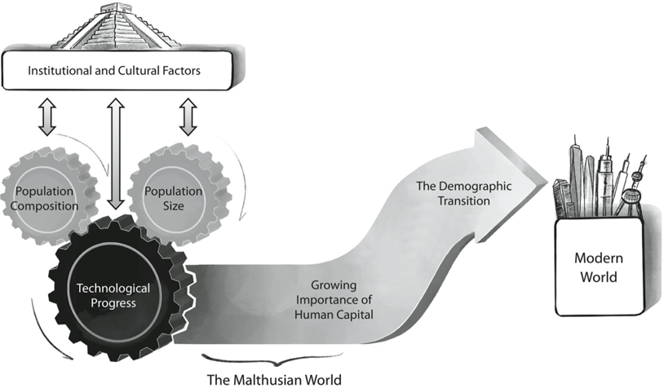

[…]Yet, a major puzzle remains unresolved: why did the cultures and institutions that were particularly conducive to technological development emerge in certain societies and not others?

## 6- Geographical Roots of Cultural Traits

At some junctures in human history, the location of cultural and institutional transformations may appear rather arbitrary; one can imagine a counterfactual history in which North Korea became a capitalist powerhouse while South Korea sank into communist poverty. However, in most circumstances, deep-rooted factors underpinned the emergence of cultural norms and institutional structures. These were geography and human diversity.

A future-oriented mindset, or long-term orientation, is one of the most important cultural traits for economic prosperity. It affects our propensity to save, acquire education, and advance or adopt novel technologies – and according to work by Dutch social psychologist Geert Hofstede it differs significantly between countries. In light of the contribution of this trait to human and physical capital formation, technological advancement and economic growth, scholars consider it to be a fundamental determinant of the wealth of nations.

The origin of this cultural trait might be traced to the geographical environment in which it evolved. Consider a society during the Malthusian epoch whose members are contemplating two possible strategies for the use of their land. The consumption strategy is to exploit the entire land for gathering, fishing and hunting, so as to satisfy the daily consumption needs of the group. This strategy guarantees a modest, yet relatively stable, year-round food supply. The investment strategy, by contrast, is to forgo some of current consumption by planting crops on part of the territory. This strategy requires some degree of long-term orientation since it involves sacrificing short-term consumption for the sake of consumption in the future.

Over the course of history, the investment strategy would have been more profitable in regions where crops generated a higher yield, and so in these places one would expect a larger portion of the available territory to be devoted to cultivation. Societies located in these fruitful regions have indeed enjoyed higher levels of income and, in the Malthusian era, higher reproductive success. This would have vindicated their strategy, reinforcing their favourable attitude towards long-term orientation, which will have been transmitted intergenerationally and become more prevalent in those societies. Thus, variation in crop yield could be the origin of the different levels of future-oriented behaviour observed in different regions of the world.

It is certainly the case that crop returns are distributed unevenly within and between continents. In particular, in the pre-1500 period, the dominating crops in Europe (barley) and Asia (rice) yielded almost twice as many potential daily calories (per acre) as the corresponding crop in sub- Saharan Africa (peas), while requiring only two-thirds of the cultivation period from planting to harvesting. Empirical evidence suggests that, within each continent, countries whose populations originated in areas with higher potential return on crop cultivation do tend to be more long-term-oriented, even taking into account other geographical, cultural and historical factors. Moreover, analysis based on polls conducted by the European Social Survey (2002–14) and the World Values Survey (1981–2014) suggests that people who come from regions with higher potential return to crop cultivation are predisposed to be more future-oriented.

As ever, these findings might be driven by reverse causality. This correlation could reflect the fact that societies with greater long-term orientation are the ones that choose to cultivate crops that require longer- term investment. However, the correlation is with potential caloric return, which is inferred entirely from agroclimatic characteristics, rather than with the actual crops that were grown in a region; the fact that such characteristics are (largely) unaffected by human choice implies that reverse causality is not at play. At the same time, the fact that the potential crop yield is (unsurprisingly) highly correlated with the actual one suggests that crop yield is indeed the mechanism that triggered the evolution of this cultural trait.

Yield is not the only aspect of crops that translates geographic conditions into cultural traits. The type of cultivation they require can also do so. Evidence from Chinese regions suggests that the suitability of land for the cultivation of rice – which requires large-scale and therefore shared irrigation systems – has contributed to more collectivist, interdependent culture, whereas land that is suitable for the cultivation of wheat, which requires a lower degree of cooperation, has contributed to the emergence of more individualistic cultures. Likewise, comparison between countries suggests that land suited to more labour-intensive crops is also associated with the emergence of more collectivist cultures.

[…]

Geographical characteristics are therefore some of the ultimate forces that set the evolution of culture, institutions and productivity in motion. They are among the deep-rooted factors affecting the great cogs that drive the journey of humanity, hastening the emergence of growth in some places and delaying it in others. In conjunction with cultural and institutional characteristics, they have contributed to the timing and the location of the technological outburst of the Industrial Revolution and ultimately to the onset of the Demographic Transition. They reveal some of the roots of the disparity in the wealth of nations today and so provide the clues to how we might address it.

### Figures quoted in the text

Figure 1. The Mystery of Growth

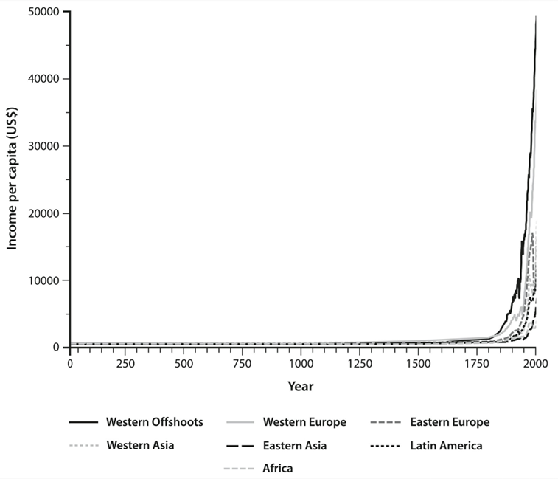



Figure 4. Effects of Technology Level on Population Density and Per Capita Income across Countries in the Year 1500

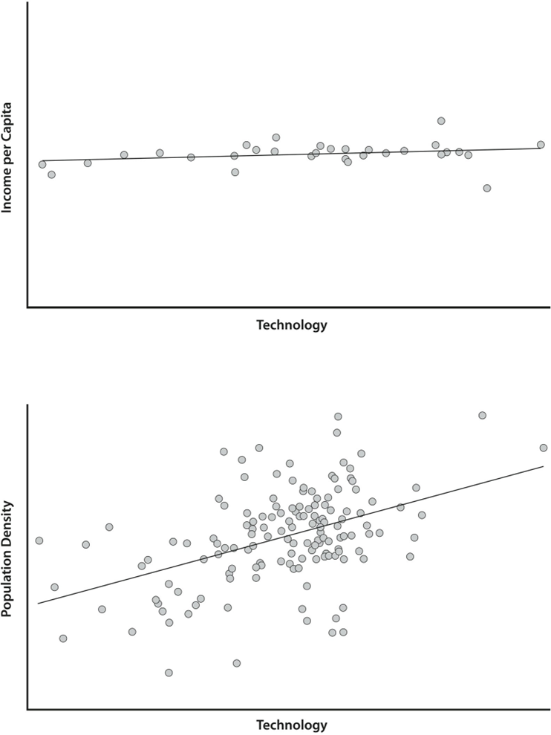

Figure 6. Human Population Growth during the Malthusian Epoch

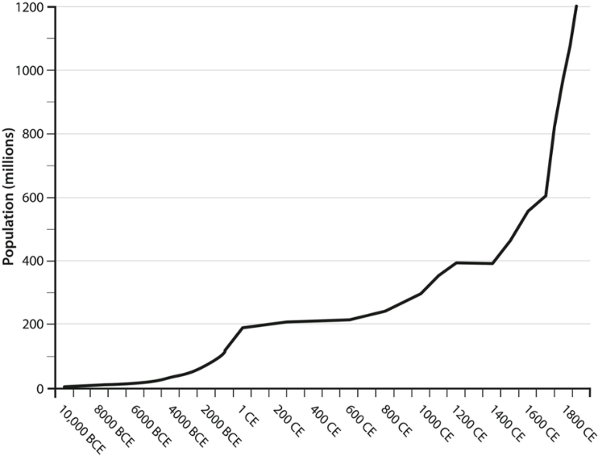

Figure 10. Evolution of Life Expectancy (at birth) across the Globe, 1613–2013[2]

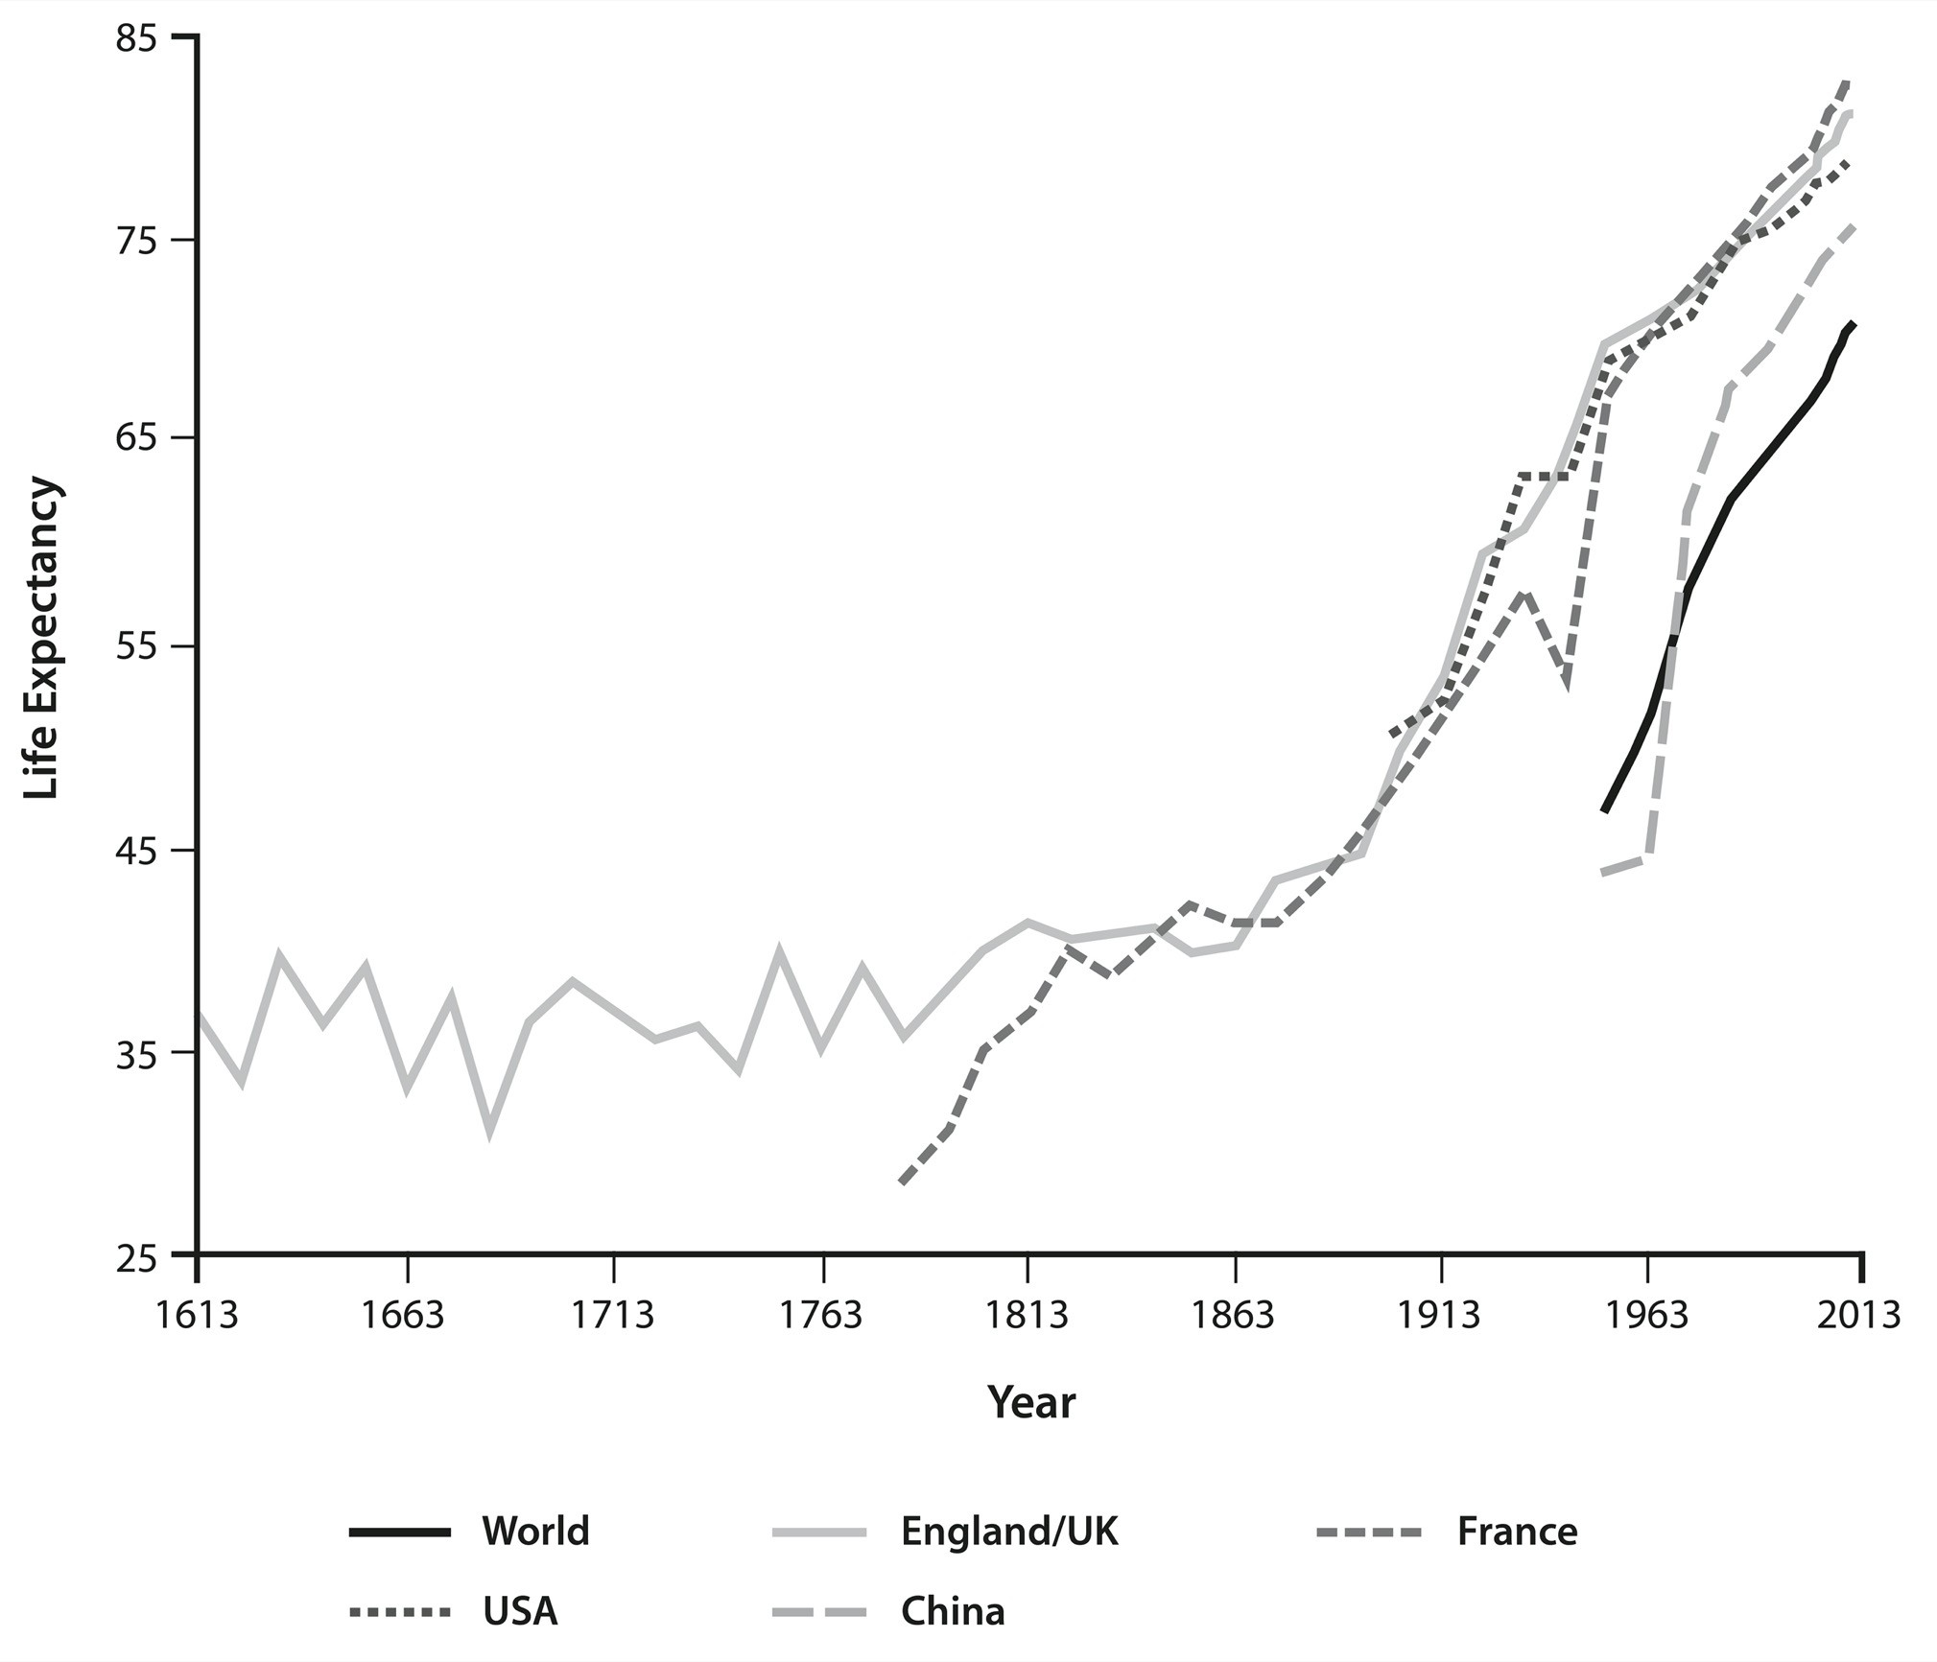

Figure 14. Income Per Capita in US Dollars, 2017[3]

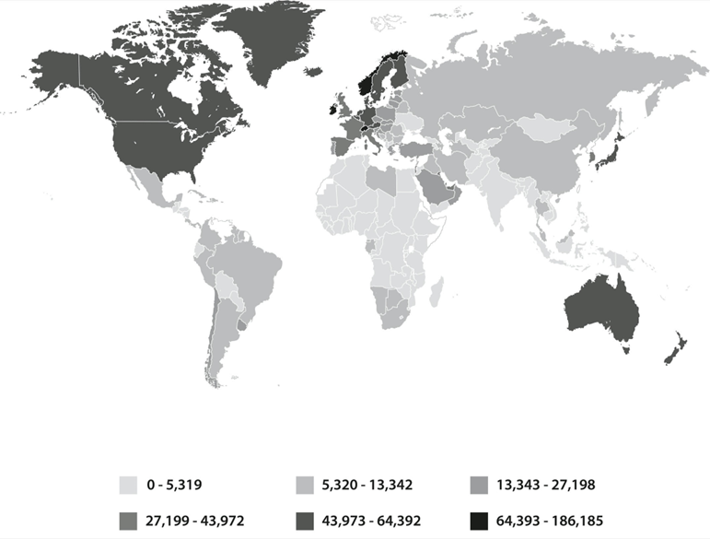

Figure 15. Evolution of Per Capita Income across Countries, 1850-2016

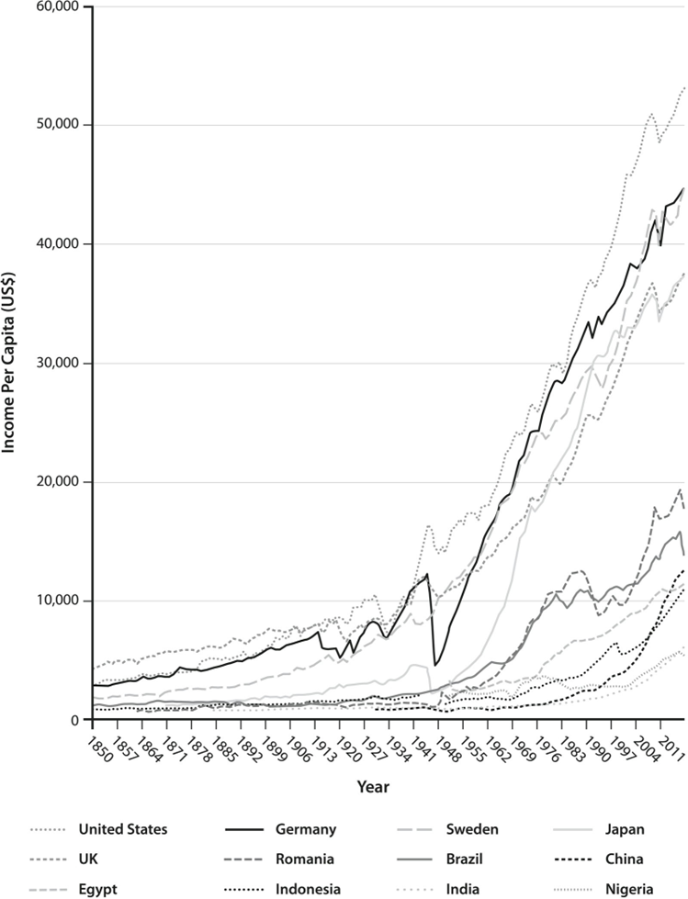

1. For the sake of a concise reading, quotations have been erased form this summary. Figures referred to in the text are inserted at the end of the document and their original number was respected.